Annex 1
3iPET Top 100 Environmental Protection Technologies Contest
- Scope of technologies:
- Air pollution prevention: management of flue gas of industrial boilers and furnaces, control on power plant boiler flue gas. Monitoring and management of VOCs, control of automobile emission and fugitive emissions source, key technologies of clean production, air pollution abatement, control and management for indoor and public places, etc.;
- Water pollution prevention: water efficiency and conservation (water saving for agriculture, industry and urban life, and utilization of unconventional water resources), clean production, sewage treatment (domestic sewage treatment, industrial wastewater treatment, non-point source management), aquatic ecological recovery (ecological recovery for water sources, river network, large reservoirs, and wetland) etc.;
- Soil pollution prevention and solid waste disposal: recovery and remediation of industrial pollution sites, polluted farmland, mines, underground water pollution prevention and control, and recycling, valorization and management of wastes, etc.
- Participating technologies shall meet the following conditions:
- In line with environmental and sectoral policies of China;
- Valid intellectual property right or exclusive technical ownership;
- Tested and proven process; advanced, affordable and cost-effective technology,
- Evidence of practical industrial application available, and has been in operation for over one year;
- High technical adaptability, can be applied in a large scale;
- Belongs to mature process, process unit or equipment/material/agent.
- Safe, reliable, efficient and does not require the use and release of hazardous materials
- Materials to be submitted
- Application Form for 3iPET Top 100 Environmental Protection Technologies Contest (Annex 2);
- Technical Report on technology(ies) being entered into the contest (See Annex 3 for compiling requirements);
- Description of Typical Case(s) of the application of the technology(ies) (See Annex 4 for compiling requirements);
- Project acceptance report, acceptance monitoring report or performance test (assessment) report issued by a competent third party for typical case(s);
- Others: business license of legal person, patent certificate, novelty assessment report, and award-winning certificate of the recommended technologies.

Participants in the contest, other stakeholders and the general public are welcomed to follow the progress of the technology assessment and evaluation process on the WeChat of 3iPET, where the results of the contest will be posted and publicized.
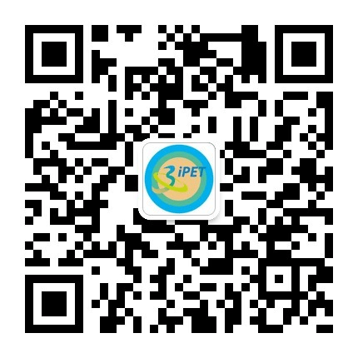

QR code of WeChat public platform of 3iPET

