Annex 4
Outline of Typical Cases of Industrial/Pilot Application of the Technology
1. Case name
2. Overview to project
In less than 200 words. Introduction to the pollution problems to be addressed,, capacity, construction, adjustment and operation time etc.
3. Description of Process Technology
（1）Process
In less than 100 words. Give a brief introduction to the process and design principle, work flow, major process indicators, and special functions; process diagram or photo of facilities can be attached.
（2）Key technological or design features
In less than 200 words. Give a brief description of process technology, innovativeness of the design, specific design considerations for scalability and upgrading; reliability and maintainability, stability and controllability; hazard and operability (HAZOP) analysis; occupational safety and health considerations;
4. Technical indicator
In less than 300 words give a brief introduction to the main pollutant, removal rate, applicable emission standard and information about meeting the standards, annual reduction volume for main pollutants, production of main by-products, operation and maintenance parameters of key equipment/facilities (e.g. filling and catalyst), indictor of secondary emission, volume of water-saving and energy-saving, etc.
5. Investment
In less than 200 words provide information on the investment including investment structure, total investment, investment per unit capacity; cost-effectiveness, financial profitability and economic viability, return on investment, projected pay-back period.
6. Operation cost
In less than 200 words. Introduction of annual consumption for raw material and energy consumption, as well as raw material consumption and energy consumption for unit capacity. Annual operation cost and operation cost for unit treatment capacity. Provide the data to show economic benefits if the project can bring by-products or prominent water-saving or energy-saving effects. Socio-economic cost-benefit analysis (SECBA).
- Comment of users
In less than 200 words provide comments and feedback from end-users of the technology(ies) about features, effects, problems, possible areas of improvement and suggestions of promotion etc.
- Contact Details
Please provide details, name, contact, telephone number, address, zip code and e-mail of contact person for technical information and further inquiry.
(Note: please refer to sample to compile a typical case; please write fewer than two cases)
Sample of Typical Case of Technology Application
- Case name
Improved UCT process××××project (××××sewage treatment plant)
- Overview to project
××××sewage treatment has a daily treatment capacity of×××m³/d. The sewage is from urban domestic and production sewage and industrial wastewater of ××××× industrial park. It started construction in ×× (MM) ×× (YY) and was put into operation in ×× (MM) ×× (YY). The project won××××××××award on ×× (MM) ×× (DD) ×× (YY). The facility since commissioning in xxx (YY) has been in continuous operation for xxxx (days or months or years) and has a total downtime of xxx (days, or months or years) for xxxx (give reasons for shutdown)
3. Introduction to process
（1）Process
The project is about the improved technology for UCT process and can realize the effects of denitrification and dephosphorization. The process is as follows: ×××××—×××××—improved UCT subsection water inflow biological reaction tank—secondary settling tank—×××××—×××××—water outflow.
The project adopts the subsection water inflow biological denitrification process and consists of 3 subsections each with anoxic/oxic area connected in series. The original water flows into the anoxic area by subsection and the sludge returns to the end of the system. The anoxic area of the first subsection uses the carbon entering the sewage Q1 to perform denitrification on NO_{x}-N of the sludge. Then the mixed liquid flows into the oxic area to perform the nitrification process. The mixed sewage after reaction flows into the anoxic area of the second subsection and uses the carbon entering the sewage Q2 to perform denitrification. The mixed liquid then enters the oxic area to perform the nitrification process. Other subsections go like that.
（2）Key technological or design features
- The process adopts ××××××××××water inflow method and process control to perform denitrification and dephosphorization, so as to increase the removal rates for total nitrogen and phosphorous
- Establish×××××, ×××××, ×××××control system, promote the automatic control.
- New technologies such as subsection water inflow×××××, ××××× and ××××× are applied, thereby stabilizing the water flow.
- Deep denitrification can be realized if an extra carbon source is added.
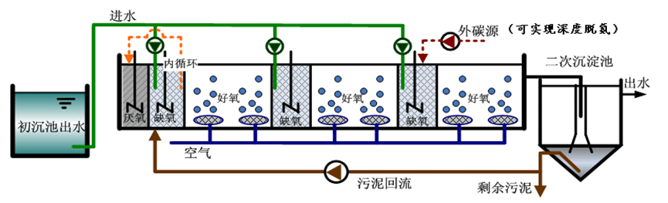

Fig. X-X improved UCT Technical Process (or photos of facilities)

4. Technical indicator
According to the acceptance report released by ×××，the water outflow of the project has met the type A class 1 standard of GB18918-2002 Discharge Standard of Pollutants for Municipal Wastewater Treatment Plant. The sewage treatment plant reduces total nitrogen emission by ×× tons and ×× tons a year, if average water inflow TN is ××mg/L and TP≦××mg/L. By adding extra proper carbon source and coagulant, deep denitrification and dephosphorization process can be realized (TN≦×mg/L，NH4⁺-N≦×mg/L，TP≦×mg/L0. The technology has been proven prominent in energy saving (per ton power consumption reduced by ×% and save ×× Kwh of power a year)
- Investment
The total investment for the project is about ×× yuan, of which, equipment investment is ××yuan, infrastructure investment ×× yuan, other investment ×× yuan, and investment for per ton water×××× yuan. The life of main equipment is ×× years and the payback period is ××years.
- Operation cost
According to the actual operation from ××(MM)××（YY）, the annual sewage treatment capacity is ×× tons, annual operation cost ××yuan, and operation cost ×× yuan. Use the process to add proper external carbon source and coagulant to realize a deep treatment. The added carbon source was ×× tons and added coagulant was ×× tons. Thus the annual operation cost will be increased ××yuan and operation cost for per ton of water will be increased by ×× yuan.
- Comment by users
The project has brought prominent economic benefits to our company. It is a demonstration project deserving promotion and application. The project has shown excellent technical indicators and met the design requirements for effluent water specifications/standards. It is of great significance to boost ××××××. ×××××× of the technology is expected to be renovated, so as to strengthen×××× and improve ××××.
8. Contact
For more information, further and commercial and technical enquiries please contact:
Name: ××××××
Title: xxxxxxx
Tel：××××××
Address：××××××
Zip code：××××××
E-mail：××××××

