Gender Mainstreaming Standard
Of Foreign Economic Cooperation Office

This policy applies to GEF funded projects

Chapter I Policy
FECO will strictly abide by the “Law of the People’s Republic of China on Protection of Women’s Rights and Interests” and other relevant laws and regulations and stick to the principle of gender equality in institutional operation and business activities, ensuring:
(1) both male and female staffs get equal opportunities for development;
(2) both male and female beneficiary groups get equal rights and interests through the development and implementation of the project;
(3) project implementation would not bring about adverse impacts on the affected male and female groups, that would result in gender inequality;
(4) both men and women would be fully respected and their human rights would be fully ensured.

Chapter II Institutional Structures
FECO will designate one staff person as the Gender Mainstreaming Focal Point, who is a member of the Women’s Committee of FECO. This staff is responsible for the coordination, implementation and oversight of the gender mainstreaming policy.
FECO will maintain a pool of gender specialists who can be contracted to perform specific functions in the implementation of the gender mainstreaming aspect in the project cycle and to manage capacity building programs to the staff and, mainly, to the Focal Point.

Chapter III Guidelines

Section I Definition of Gender Mainstreaming
As for the concept of gender mainstreaming, the expression in the Plat for Action adopted at the 4th World Conference on Women is that: “In addressing the issue of mechanisms for promoting the advancement of women, Governments and other actors should promote an active and visible policy of mainstreaming a gender perspective in all policies and programmes so that, before decisions are taken, an analysis is made of the effects on women and men, respectively.”
In 1997, the Economic and Social Council of the United Nations (ECOSOC) adopted a consistent definition of gender mainstreaming, i.e., “mainstreaming a gender perspective is the process of assessing the implications for women and men of any planned action, including legislation, policies or programmes, in any area and at all levels. It is a strategy for making the concerns and experiences of women as well as of men an integral part of the design, implementation, monitoring and evaluation of policies and programmes in all political, economic and societal spheres, so that women and men benefit equally, and inequality is not perpetuated. The ultimate goal of mainstreaming is to achieve gender equality.” Gender mainstreaming is not a goal in itself, but a means to achieve gender equality.

Section II Gender Analysis
Gender analysis mainly includes the following aspects:
I. Collection and analysis of gender disaggregated data
Gender disaggregated data refers to the data and information on disparities and inequalities between women and men, which allows us to understand the disparities between women and men on the aspects of living conditions and social status, and the collection and analysis of gender disaggregated data is the first step to conduct a gender analysis.
Gender disaggregated data includes both quantitative data and qualitative data; it includes both the data collected from literature materials and the oral data collected from farm fields. Therefore, when collecting gender disaggregated data, both quantitative research methods (i.e., directly obtain data from statistical department or other relevant departments, or investigate the targets by using questionnaires) and qualitative research methods (i.e., case interviews, panel discussions and on-the-spot investigation) should be used, and literature research should be carried out if necessary.
II. Gender analysis on the division of labor, resource acquisition and control, as well as decision-making
In different regions, men and women have different roles and powers on the aspects of division of labor, resource acquisition and control, as well as decision-making, and therefore, it is necessary to analyze these situations in project design and implementation, specifically including the following aspects:
(1) Analysis of roles and division of labor of both men and women in the processes of production and reproduction: When and Where? How to do? Who are the beneficiaries? How to benefit? Who is more marginalized?
(2) Analysis of the differences between men and women on the aspects of control and use of resources and decision-making (What kinds of resources can be used by whom? Who are the final decision-makers on resources? Who shall participate in the decision-making process? Etc.).
III. Identification of men and women’s needs for the project
By analyzing men and women on the aspects of division of labor, resource acquisition and control, as well as decision-making, the current social status of men and women can be understood. Then, it is necessary to analyze men and women’s needs for project, understand their different needs, and evaluate whether existing policies meet their different needs, what are the adverse effects and limitations on them, and how to integrate the needs of target groups with different genders into proposed project or plan, so as to achieve the purpose of gender mainstreaming.
IV. The opportunities and constraints that are brought about by relevant laws, policies, social economy and cultural backgrounds for men and women should be further analyzed at a macro level
A project itself will have different constraints and challenges on men and women; in addition, the country's major policies and principles, economic policies and cultural atmosphere of the whole society also have different influences on men and women, as well as the implementation of the project. Therefore, in order to perform a deeper analysis, it is necessary to analyze relevant laws, policies, social economy and cultural backgrounds at a macro level, so that the opportunities and limitations of these macro backgrounds on men and women can be fully understood.
V. Recommendations
After performing the above analysis, targeted and practical recommendations should be proposed to address the problems identified.

Chapter III Procedures
I. Stage of Eligibility Assessment
FECO’s Requests for Project Concept Document (PCD) include a section asking proponents to explain how the proposed project will promote gender mainstreaming and give visibility and importance to the roles and contributions of both men and women. This information will be the base for the institutional Gender Mainstreaming Focal Point to determine whether the standard on gender mainstreaming is triggered.
If the standard on gender mainstreaming is triggered, a gender analysis will be required. The Focal Point may need to hire specific consultants to help with the work if necessary.
II. Stage of the Project Document Assessment
Depending on the results of the gender analysis, the Focal Point may ask the proponent to develop activities that will enhance its gender mainstreaming capacity, providing technical assistance when necessary.
In projects where there is a potential for adverse effects, then mitigation and/or compensation mechanisms should be developed in collaboration with the groups that may be negatively affected and these should be included in the project design.
In projects where there is a potential for generating benefits, then specific mechanisms for the equitable distribution of social and economic benefits in gender sensitive ways should be developed collaboratively with the potential beneficiaries of the project and these should be included in the project design.
The mechanisms mentioned may require holding meetings with the affected community or with specific organizations, such as women’s associations, neighborhood committees or cooperatives.
III. Monitoring and Evaluation
For projects which trigger gender mainstreaming standard, FECO’s regular process of project monitoring incorporates specific items that assess gender-sensitive issues. This portion of the monitoring process will be supervised by the Gender Mainstreaming Focal Point, with the support of external gender specialists if needed.
During project implementation, participatory and gender-sensitive methods for monitoring and evaluation should be adopted, so as to facilitate stakeholders express their ideas more fully and participate in the project.
The final evaluation of the project will incorporate the cumulative results of the monitoring of the indicators and assess the adequacy of the implementation of FECO gender mainstreaming policy.
FECO has developed the methodology for monitoring and evaluation of gender mainstreaming (see Appendix I) and an indicator system including two levels and four dimensions (see Appendix II). For a specific project, appropriate indicators shall be selected and detailed based on the characteristics of the project to form a specific indicator system.

Appendix I:
FECO Gender Mainstreaming Methodology

Recent years have witnessed some progress in social gender equality. However, women are still in a weak position, as there still exists gender binary opposition stereotypes and gender mainstreaming still needs advocacy and practice.

The Foreign Economic Cooperation Office, Ministry of Environmental Protection (hereinafter referred to as FECO) has recognized gender discrimination and inequality and therefore taken gender mainstreaming as an important part of its mission, focusing on improving the rights and interests of women and encouraging balanced gender participation and equality in environmental protection.

According to its own characteristics and mission, FECO has established seven steps and methods to achieve gender mainstreaming.

- Adhering to the “gender sensitivity” commitment and advocacy

FECO focuses on gender mainstreaming commitment and advocacy. Specifically speaking, FECO adheres to a positive “gender-sensitive” policy, promoting gender equality and gender-related development.

“Gender sensitivity” is used to gauge whether a decision or activity has the same effect on both men and women. It is necessary to consider the different needs and manners of men and women and narrow the gap in gender benefits on the basis of respect for differences.

Specifically, FECO will fulfill the following commitment and advocacy:

1. FECO shall introduce “gender sensitivity” into its purpose and strategy, taking gender equality as one of its fundamental principles and developing relevant measures;

2. FECO shall have its management use separate data for men and women in public speeches and publicity campaigns, taking gender perspective as an analytical category;

3. FECO shall have each of its own planning and project implementation plans crafted from a “gender-sensitive” perspective;

4. FECO shall have its gender equality commitment reflected in concrete budget and resource allocations, and ensure the proper implementation of related policies and programs. Resource assurance includes funds to achieve gender equality and appropriate institutional and human settings.

FECO shall hold meetings to discuss the implementation of gender-related decisions and evaluations, establishing a team of experts in charge of development and improvement of gender mainstreaming, striving to document annual gender statistics and analysis, regularly communicating with the media, publishing progress in gender equality, applying experience and lessons to the future work, forming a gender mainstreaming system characterized by self-correction and self-improvement.

- Improving institutional configuration, promoting women participation

Improvement of the status of women and gender equality depends not only on awareness raising but also on institutional assurance in which the institutional setting is a very important part. FECO shall ensure a sound institutional configuration, and promote women participation and gender balance in the following three respects:

1. FECO shall establish its internal gender equality mechanism consisting of a special cross-office and interdisciplinary coordination mechanism, which can be called “Gender Coordination Group”, to effectively coordinate resources and implement gender equality in specific work, and "gender mainstreaming coordinators" to regularly convene joint meetings of the principals of departments or projects to have communication and coordination on gender equality.

2. FECO shall establish a cooperation mechanism with the project executing agency. In addition to internal mechanisms, FECO shall strive to develop platforms for the project implementation agencies, encouraging them to establish cooperation mechanisms for gender equality, strengthen communication on gender issues, sharing experience and information, and enabling the project to achieve its gender equality goals. FECO shall encourage the project executing agencies to develop their own gender equality network systems, integrating efforts to promote gender equality understanding and application.

3. FECO shall regularly collect statistics on the gender proportion of participants, ensuring that women representatives will account for 30% in decision and program making so as to constitute an effective group and influence decision-making. It is not necessary to pursue a gender proportion of 50% vs. 50% in all aspects of the project, but a proper gender proportion is an important indicator of gender balance.

FECO shall constantly improve its gender sensitivity institutional configuration, taking it as gender mainstreaming structural protection.

- Developing ongoing capacity, closing the gender gap

Failing to be achieved with commitment and institutional configuration naturally, gender mainstreaming wants relevant decision-makers, implementers and participants to have certain gender awareness and capacity, especially gender analysis, planning, implementation and evaluation capacity.

FECO shall cooperate with universities, research institutions and international organizations to carry out a series of gender awareness and gender mainstreaming training programs, including those related to gender-awareness training, gender project design training, gender budgeting training, and gender assessment training.

Specifically, the following steps are to be taken:

1. FECO shall conduct a survey of the needs of the project-related personnel. Before the project design and implementation, it is necessary to examine and assess gender awareness of project-related personnel, including their views of gender equality, their gender-related experience, background and expectation for the training so as to better design the gender training.

2. FECO shall determine training objectives and content. FECO and project executing agencies are different in gender-related experience, and FECO shall take differentiated training, designing training of different depths and breadths according to the characteristics of participants. Please see the table below for the detail:

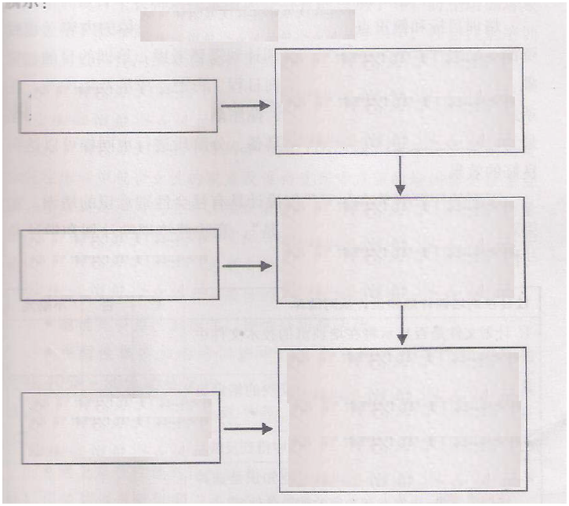
有针对性的培训设计
Targeted training design
针对那些从来没有接触过社会性别概念和内容的人
For those who have never been exposed to gender concepts and content
提升社会性别觉悟的培训：提高参与者的社会性别觉悟，主要包括提高对社会性别基本概念及其意义的认识，启发参与者进行反思和思考
Gender awareness enhancing training: Improving gender awareness of participants, including improving their basic gender concepts and inspiring them to reflect and think
针对知晓社会性别概念，但需要知道如何运用社会性别概念进行分析的人员
For those who know gender concepts, but need to know how to apply them
掌握社会性别分析方法的培训：参与者在了解基本概念基础上，学习掌握社会性别分析工具，学会从社会性别视角发现和分析问题。
Gender analysis training: Participants shall understand the basic concepts and then master gender analysis tools and identify and resolve problems from the gender perspective.
制订社会性别计划的培训：参与者在了解基本概念，掌握基本分析方法基础上，根椐社会性别分析的结果，结合自己工作实际，寻找解决问题的对策，制订具有社会性别敏感的计划和方案，设计评估指标。
Gender program development training: Participants shall understand the basic concepts and master basic analysis methods, and then, based on the results of gender analysis, and taking their actual work into account, find solutions to problems and develop gender sensitivity plans and programs, and design evaluation indicators.
针对具有一定社会性别意识并掌握了一定分析方法的人员
For people with a certain degree of gender awareness and mastery of certain analytical methods

3. FECO shall design, implement and evaluate training programs. After the theme is determined, FECO shall begin to design, implement, and evaluate the training programs. FECO has designed a checklist for each link, indicating the gender program to be inquired about and completed in each stage, stressing gender participation especially men participation, achieving men and women balanced participation. It is necessary to stress that gender issues should be a matter of concern to everyone, not just women.

4. Training reports and follow-up activities. After the training, FECO shall encourage exchanges of reports, and follow-up plans and practices, trying to develop an exchange and sharing platform to participants, making the effect of training continue to play a role, and really have an impact on practices.

Only through completion of capacity development can it become possible to implement gender equality and assure gender mainstreaming in a meaningful manner.

- Establishing a gender analysis and evaluation system

Gender analysis is an important tool to achieve gender mainstreaming. Popularity of the concept of gender is one of the goals of gender mainstreaming. It is emphasized that the gap between men and women is determined by physiology and more important by culture, and therefore can be changed. It is necessary to oppose binary opposition as well as the belief that “men and women are the same”. It is necessary to start from the perspective of differences and emphasize uniqueness of men and women, which is not directly related to gender. In development, social judgment of an individual cannot be based on group attribute. It is necessary to have analysis and judgment according to specific circumstances.

Against this concept, FECO focuses on the following two aspects in gender analysis and assessment: First, having gender statistics and analysis; Second, having development free from “gender gap” and having analysis and assessment. Specifically, FECO shall analyze and assess the following:

FECO shall identify the impact of different roles, needs, institutions, policies, programs or activities of men and women on different gender groups in institutions, policies, projects or activities so as to achieve the sensitive goals of policies and projects;

FECO shall analyze and summarize the past experience of institutions, policies, projects or activities in promoting gender equality;

Identifying the areas where the problem of gender inequality lies, and making specific suggestions for future development and improvement;

Including gender analysis and assessment into capacity development, making participants understand the concept of gender and make comments and suggestions on their situation, promoting dialogues between various parties.

To achieve the above objectives, FECO shall specifically complete the following:

FECO shall collect and analyze gender data and information, focusing on quantitative and qualitative combination, historical and present comparisons, comprehensive understanding and assessment of gender equality in environmental protection.

FECO shall apply gender analysis frameworks and evaluation framework for data and material analysis: The relatively mature gender analysis frameworks are: Harvard Analytical Framework, Moser Framework, Parker Gender Analysis Framework, capacity and vulnerability analysis framework, women empowerment framework and social relation analysis method. The relatively mature gender assessment frameworks are: Gender need assessment framework and gender impact assessment framework. FECO shall select, analyze and evaluate appropriate frameworks according to the specific situation and the project.

FECO shall assist the project executing agencies in developing and achieving gender analysis frameworks and evaluation system in line with their specific circumstances so as to promote gender equality.

Gender analysis and assessment is the starting point and junction point of gender mainstreaming, an important part of gender mainstreaming. In general, gender analysis begins with the design and implementation of the agency or project. Assessment is usually at the stage of results of the project. Gender analysis and assessment influence each other. Different assessment objectives will affect analysis perspectives, and analysis focus will be included into assessment content. Therefore, the two are complementary to each other.

- Establishing a gender statistic system

Statistics and indicators reflecting women status and men status are important tools to promote gender equality. Gender statistical methods play an important role in eliminating prejudices, developing policies, and inspecting development.

FECO gender statistical system has the following characteristics and connotations:

1. Materials with individuals as the statistical unit should be collected, sorted, and presented by (physiological) gender;

2. All variables and characteristics are analyzed and presented as gender-conscious and comprehensive items;

3. Relevant information collection and statistics accord with gender issues to be analyzed and discussed;

4. In environmental protection, gender statistics focuses on gender-based differences and therefore gender statistics and gender differences related issues are reflected in the survey;

5. Gender equality and gender development indicator system defined by FECO are applied to design various statistical variables and assess them from a gender perspective;

6. Gender statistics is a continuous (even traceable), representative, and cross-cutting analysis system, rather than an isolated and periodic system;

7. In projects and practices with the family as the basic unit, gender statistics distinguishes family members, ages and other backgrounds for classification statistics and analysis;

8. Gender statistics is carried out in combination with the Human Development Indicator (HDI), Gender Development Indicator (GDI), and Gender Empowerment Measure (GEM).

Gender statistics is very important. It is the basis for policy-making, project decisions, assessment and publicity. Its birth is complicated, requiring specially designed survey topics reflecting gender issues, understanding different cultures of men and women, considering gender bias. On this basis, research and announcement can be properly conducted. The following figure shows gender statistics production process.

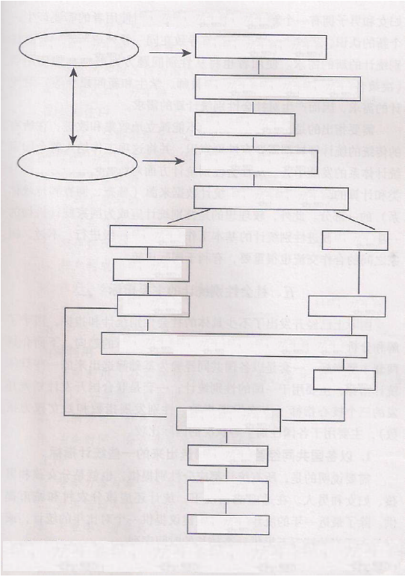
社会性别统计生产过程
Gender statistics production process
性别统计使用者
Gender statistics users
社会中存在的性别问题
Gender issues that exist in society
改善妇女和男人状况的必要性
The necessity to improve the status of women and men
平等机会的目标
Goal of equal opportunities
不同领域的统计需求
Statistical needs of different areas
有关统计和指标
Relevant statistics and indicators
性别统计生产者
Gender statistics producers
可获得统计
Available statistics
数据缺口
Data gap
资料来源
Material sources
数据质量
Data quality
可能的来源
Possible sources
对统计内容、计算方法、概念和分类的改进
Improvements on statistical content, calculation methods, concepts and classification
新数据
New data
需要分析的统计
Statistics needing analysis
分析
Analysis
展示
Presentation
发布
Release
Source: Birgitta Hedman, Francesca Perucci, Pehr Sundstrom, Gender statistics – a Tool Seeking Change, Statistics Sweden 1996.

At present, China has its gender statistics still in the development stage. There is no mature system available. FECO shall combine its own characteristics to explore gender statistics in environmental protection.

- Establishing a gender budget and evaluation system

Gender budgeting is the process introducing gender awareness into the budget at all levels. It is a means and a method used to assess the impact of income and expenditure in different organizations or projects on women and men, girls and boys. There are multiple types of gender budgeting, such as women budgets, gender sensitivity budgets, gender-responsive budgets, and applied gender budget analysis.

It should be emphasized that the gender budgeting of FECO does not mean to distribute the funds equally between men and women, boys and girls, but to meet the different needs of women and men, girls and boys and their groups from a gender perspective, while considering the different impact of the project implementation on men and women, boys and girls so as to reduce the fund required to be invested to minimize the impact.

Depending on the circumstances, FECO generally adopts 2 kinds of gender budgets: Single budget based on gender and overall budget system integrating gender sensitivity. Both budgets have advantages and disadvantages. FECO shall select the appropriate budget system based on the specific situation.

To conduct gender budget, FECO shall refer to the mature gender budget analysis framework, and design and implement gender analysis. FECO shall select the following 3 gender budget analysis frameworks:

1. South Africa - 3-type method: Gender-related expenses, equal-opportunity expenses in the public sector, other expenses impacting gender;

2. Australia - 5-step method: Analyzing the situation of men and women, boys and girls, assessing the sensitivity of the policy to gender, evaluating budget allocations, monitoring expenditures and service provision, and assessment results;

3. Gender sensitivity budget analysis tools: Gender awareness policy assessment, beneficiary assessments by gender, analysis of public spending by gender, taxation analysis by gender, analysis of the impact of the budget on time use by gender, gender sensitivity medium-term economic policy framework, and gender sensitivity budget report.

In specific project and policy implementation, FECO shall use the South African 3-type method in combination with the Australian 5-step method and the gender sensitivity budget analysis tools to design a specific gender budget analysis based on specific topics.

On the basis of a budget, FECO shall provide the assessment team with gender training, incorporating gender sensitivity into the whole system, adopting the gender budgeting analysis tools mentioned above, in combination with the budget for assessment and summary, and feedback the results in a timely manner to relevant departments and agencies or project executing agencies so as to make participants revise and improve gender equality.

- Gender program design and implementation for all projects

Gender planning refers to the process of crafting a gender sensitivity development plan or project. In plan making, it is necessary to take into account the impact of different gender roles and gender needs of the target groups. Gender planning includes selecting appropriate means, meeting practical needs of women and men, girls and boys, striving to challenge unequal gender relations, and enhancing dialogues on gender sensitivity policies.

FECO shall develop gender plans for its own institutional development and each project, trying to make the policy, program and project meet different needs and interests of men and women, achieving fair and reasonable configuration of public resources between men and women, improving unequal gender relations and women power and capacity to access and control resources, promoting participation of women and men in gender-related work, making men and women have the same representation.

Although gender plans it designs vary with the project, FECO shall in general design its gender plans according to the following principles:

1. Balancing Practical Gender Needs (PGN) and Strategic Gender Interests 9SGI) to meet the current needs of women as far as possible while focusing on the future, improving current gender division of labor and cultural environment and promoting the development of gender equality.

Practical gender needs of women refer to the needs of women in their daily life, which often stem from the traditional gender division of roles assigned to them. Strategic gender needs and interests of women are defined as the needs required by the construction of a more equitable, and better society, meaning it is necessary to have radical changes in the gender relations and structure. Sometimes there is a contradiction between the two. Some practical gender-based needs stem from the traditional unequal division of labor. Meeting the practical needs sometimes reinforces the unequal gender relations, contrary to the object and purpose. However, strategic gender benefits will probably make them pay a higher price instead of have their needs met. Therefore, FECO takes introducing the concept of gender sensitivity, balancing the two genders, meeting the real needs of women under the framework of promoting gender equality as one of the principles it sticks to in conducting gender planning and plan execution.

2. Establishing Gender and Development (GDP) strategy. Different from the previous strategy of women participation in development, the gender strategy focuses on gender relations coordination and gender structure review, emphasizing gender equal participation in different aspects instead of unilateral emphasis on women participation. The objects include women and men. The gender strategy focuses on sustainable and harmonious development, encouraging active participation of women and men in different aspects, trying to improve the role of women in decision-making, promote joint development of gender interests, and establish partnership between women and men.

3. Adopting dual gender equality strategy. FECO refers to the dual gender equality strategy adopted by multiple mature organizations to advance their gender programs, which means that on the one hand gender mainstreaming is included in all policies, programs and actions, and equal participation of men and women is encouraged, on the other hand gender measures or special events for women are conducted so as to improve women capacities in all respects so as to achieve the goal of women empowerment. “Dual strategy” introduces gender equality into the mainstream in the development of gender plans and jobs and projects developed for women. (See figure below for the detail)

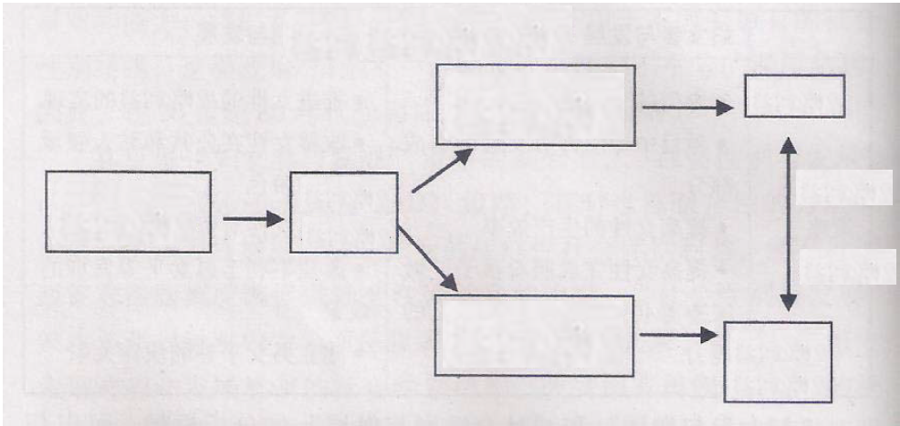
“双头战略”示意图
Dual strategy diagram
目标：社会性别平等
Objective: Gender equality
策略：双头战略
Strategy: Dual strategy
将社会性别议题纳入所有政策和项目
Incorporating gender issues into all policies and projects
男女平等
Gender equality
开展赋权妇女的专门政策和项目
Carrying out specific policies and projects for women empowerment
妇女权力增长
Growth of women rights
产出
Outputs

FECO shall promote women participation in program development and decision making, making their voices heard. Referring to the indicators of women participation in use at the United Nations, in program setting and decision making, FECO arranges women to account for more than 30% so as to make their voices heard. Specifically, FECO examines the following indicators: whether the proportions of men and women plan developers are balanced, whether the proportion of women plan developers exceeds 30%, whether gender experts are hired in program developing, whether the proportions of men and women beneficiaries are balanced, and whether there are differences between men and women benefits.

In the implementation of the gender program, FECO shall constantly improve gender sensitivity awareness of performers and participants, establish mechanisms for consultation and research, provide timely and effective information services and technical guidance, establish platforms for exchanges of information and experience, conduct rigorous monitoring and evaluation, and incorporate implementation of gender equality into the project appraisal.

In order to facilitate implementation, FECO has referred to the experience of some international agencies, and has designed its gender mainstreaming indicator system, which will effectively enable each project to have a detailed gender program guiding framework.

Through the above 7 steps and methods, namely adhering to the “gender sensitivity” political commitment and advocacy, improving the institutional configuration, promoting women participation, ongoing capacity developing, closing the gender gap, establishing a gender analysis and evaluation system, establishing a gender statistics system, establishing a gender budgeting and evaluation system, and making each project have gender program design and implementation, FECO is confident in implementing gender mainstreaming and making it a requisite analysis perspective of its and an assessment tool, so as to promote gender equality in environmental protection.

Appendix II:
FECO Gender Mainstreaming Indicator System
Institutional Level
Indicator | Goal | Specific indicators
Human resources | Promoting women participation, establishing a gender-friendly working environment, reducing women life deterioration caused by changes in climate, soil, pollution and other environmental factors, developing their adapting and regulating capabilities so as to achieve gender equality in access to various resources. | Proportion: Agency gender proportion and configuration  Data: Establishing specialized gender work groups or liaison officers  Evidence: Creating a gender-friendly working environment  Figure: Gender time ratio in participation in various activities  Evidence: Compared with men, women position in access to various resources (can be supplemented)  Figure: Absolute numbers and proportions of women and men surviving and developing on nature  Evidence: Different impact of changes in climate, soil and other environmental factors on men and women
Economic empowerment | Gender equality in control, employment, income, information and financial services and other economic opportunities in resources, services and properties (such as land and forests). | Proportion: Compensation proportion of man and women staff  Figure: Changes in income of women and men caused by agency activities  Figure: Women loans and other financial services  Figure: Gender budget and audit
Voice and rights | Women decision-making influence in public and private sectors, including the family, market, governmental agencies, representative systems and social organizations, and elimination of gender discrimination and women social status improvement | Proportion: women influence in decision making  Proportion: Expression of opinions of women and men on related activities  Figure and material: Specific measures to eliminate gender discrimination  Evidence: Impact of public activities on family affairs
Gender capacity development | Women capacity development and equal benefits in design, implementation and evaluation of policies, projects and programs. | Evidence: Whether the gender analysis method is taken to weigh the impact of changes in natural environment on women and men  Data and evidence: Number of times and quality of men and women in respect to gender training  Evidence: Gender sensitivity utilization at all levels

Project level
Indicator | Specific indicators
Human resources | Proportion and configuration of women participation in the project | Figure: Number of women participating in activities  Proportion: Proportion of women participation in activities  Proportion: Proportion of women taking lead in decision making
 | Women’s and men’s benefit in the project training | Figure: Number of families involved in the project  Proportion: Gender proportion of participation in training  Figure: Proportion of gender training in all training programs  Evidence: View of men and women on impact of the project on natural environment
 | Improvement of women and men from different projects | Evidence: Women's and men's assess to project resources  Evidence: Proportion of women and men in technical growth  Evidence: Changes in women working environment
Economic empowerment | Gender proportion of project participants | Proportion: Number and proportion of women professionals  Evidence: Priority of women in employment
 | Contribution of the project to women employment | Figure: Number and proportion of women employment driven by the project  Evidence: Design of the project promoting women employment and development
 | Project funding to women | Figure: Funds offered to women by the project  Proportion: Proportion of women and men in obtaining project funds  Evidence: Project additional fund support to women
 | Economic benefits | Figure: Whether men and women benefit plans are clear
 | Gender statistics | Data and figures: Gender statistics progress
 | Gender budget | Evidence: Reasonable and fair gender budget
 | Gender assessment | Evidence: Whether men and women are equal in economic benefits
Voice and rights | Men and women enjoy equal participation in the project | Figure: Numbers of women and men involved in project implementation  Proportion: Proportions of women and men participating in relevant meetings and training courses
 | Effective protection of women rights and interests | Evidence: Improving the critical status of women caused by changes in natural environment  Figure: Whether the project poses physical or psychological risk to women participants  Figure: Indicators weighing men and women benefits
 | Improvement of women capacities of understanding and analyzing environmental protection policies | Figure: Women participating in public discussions  Evidence: Specific measures to eliminate gender discrimination and improve women status
Gender capacity development | Men and women's participation in gender training | Data: Proportion of men and women participating in the project gender training  Evidence: Providing gender analysis tools for project staff
 | Women capacity development and equal benefits in design, implementation and evaluation of policies, projects and programs | Evidence: whether gender analysis is taken to weigh different impacts of changes in natural environment on women and men  Data and evidence: Number and quality of participation in gender training  Evidence: Gender sensitivity utilization at all levels, ensuring gender issues are emphasized in project training  Evidence: Providing gender mainstreaming information and data for project participants
 | Communication platform development | Evidence: Establishing a women communication platform  Evidence: Regularly engaging gender experts
 | Project evaluation, summary and feedback | Evidence: Project evaluation, summary and discussion from the gender perspective  Evidence: Following up feedback

